SHOTPUT QUICK REFERENCE GUIDE
Safety tips
- Make sure all helpers and other athletes not throwing, stand behind the athlete while a throw is in progress.

Equipment Needed | SETUP – Officials
- Tape measure  - Assorted discus  - Spike for marking | - One parent on measuring spike  - One parent to measure distance & check for foul throws  - One parent to marshal athletes & record measurements

Shot Put Weights
Age Group | Weight (kg)
U6-U7 Girls & Boys | 1
U8 Girls & Boys | 1.5
U9-U12 Girls & Boys | 2
U13-U16 Girls  U13-U14 Boys | 3
U15-U16 Boys | 4

Number of Throws
- Each athlete will have 3 puts, normally one at a time. However, an athlete may take 3 throws consecutively, with only the best throw measured.
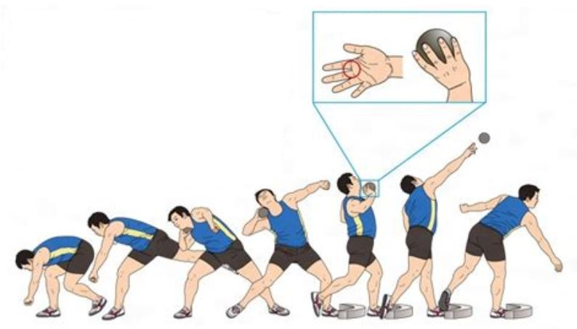
Valid Throw
- The put must be commenced from a stationary position inside the circle.
- The athlete must not leave the circle until the shot has landed.
- The athlete must not touch the top of the circle or stop/kick board, or the ground outside the circle during the put with any part of their body. They are allowed to touch the inside of the circle or stop/kick board.
- The shot must land in a manner whereby the ‘impact mark’ is within the inner edges of the lines marking the sector.
- The athlete may enter the circle from any direction (preferably from the rear half of the circle) but must exit from the rear half of the circle.
- The shot shall be put from the shoulder with one hand only. At the start of the put, the shot shall touch or be in close proximity to the neck or chin and shall not be dropped below this position during the action of putting.
- The shot must not be brought from behind the line of the shoulders.
- The athlete may during the course of each put, stop and place the shot down in the circle and then recommence the put again, providing that no other infringement has occurred.
- Once competition has begun, athletes shall not be permitted to use the circle or ground within the sector for practice puts with or without implements.

Method of Measurement
- Officials select the ‘imprint mark’ made by the shot on landing
- The selected point is marked by the spike and the zero end of the tape is held at the spike.
- The tape is drawn tight through the centre of the circle.
- The distance is measured at the point where the tape crosses the inner edge of the circle.
- Each measurement is to the nearest cm below the distance put

Recording
X should be used to indicate an Invalid Throw
Athlete | 1st Throw | 2nd Throw | 3rd Throw | Best | Place
A | 4.60 | X | 4.62 | 4.60 | 3
B | 5.35 | 4.92 | 5.88 | 5.88 | 1
C | 4.65 | 4.35 | 4.75 | 4.75 | 2
D | X | X | X | NM | NM

- Results will always show “NM” when an athlete fails to record a measurable trial.

